**OLX Technical Assessment**

**South African Telephone Numbers**

Author: Nathanyel Sandi

1. **– Running the application** 
   1. **Setting up local database requirements**

For run the web application is necessary have installed the follow tools in your computer:

* 1. Eclipse
  2. Apache TOMCAT 9.0
  3. Microsoft SQL Server
  4. Spring + Hibernate (Libraries already included in the project)
  5. **Running the application though Visual Studio**

Before run the application on Visual Studio, it’s necessary to execute the scripts in order to create database and table to storage data. These scripts are located in the project root folder named as “OLXQueries.sql”, as showed in the follow image:

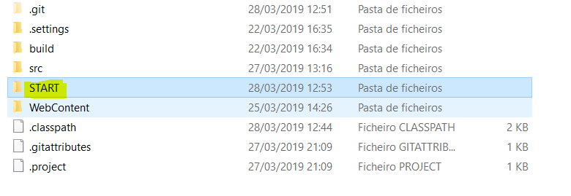

The next step is open the project on eclipse, its necessary to update the setup of database in the xml called hibernate.cfg:

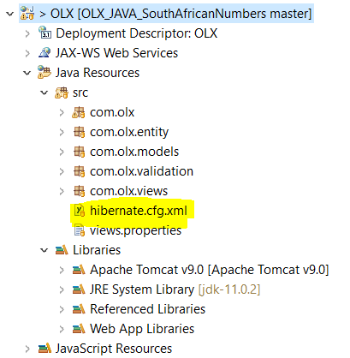

The follow tags must be updated according to your database configuration

|  |
| --- |
| <property name=*"connection.driver_class"*>com.microsoft.sqlserver.jdbc.SQLServerDriver</property>  <property name=*"connection.url"*>jdbc:sqlserver://localhost;databaseName=OLX;</property>  <property name=*"connection.username"*>sa</property>  <property name=*"connection.password"*>nathan123</property> |

If your database is local, after the execution of scripts, just replace the user id and password to yours.

1. **– Functionalities**
   1. **File Upload (**[**/OLX/**](http://localhost:8080/OLX/) **endpoint)**

**In this endpoint, the user is able to upload the file with the South African Numbers in the right template.**

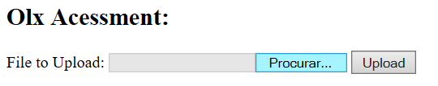

Validation Cases:

|  |  |
| --- | --- |
| **Case** | **Message** |
| **Wrong Format** | Please upload valid .csv file only |
| **No file updated** | File can not be empty |

* 1. **Analysis (OLX/dbanalysis endpoint)**

**In this screen is possible to see the analysis of the files uploaded and also download the result of numbers processed by the user.**

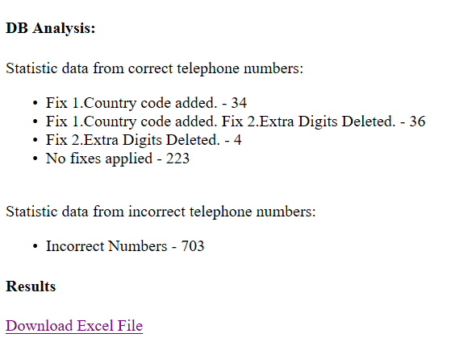

* 1. **Test endpoint (OLX/test)**

**In this endpoint, the user is able to test a single telephone number, and as output, user receives a message that is described in the validation cases. The follow image is showing the screen that is expected accessing this endpoint.**

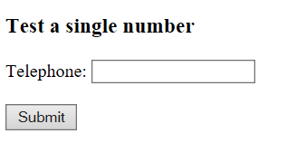

Validation Screen:

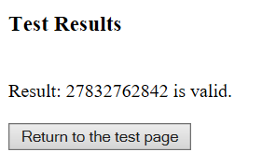

Validation Cases:

|  |  |
| --- | --- |
| **Case** | **Message** |
| **Wrong Format** | Result: ____ is invalid |
| **Right format** | Result: ____ is valid. |
| **With fixes** | Result: ____ is valid, but has fixes: Fix 2.Extra Digits Deleted. |

Test Examples:

|  |  |
| --- | --- |
| **Input** | **Output expected** |
| 27832762842 | Result: 27832762842 is valid. |
| 278327628420 | Result: 27832762842 is valid, but has fixes: Fix 2.Extra Digits Deleted. |
| 323232311 | Result: 323232311 is invalid |